1. 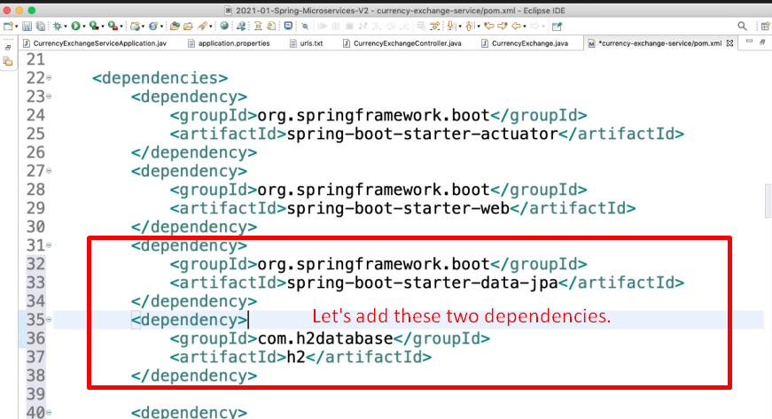
2. 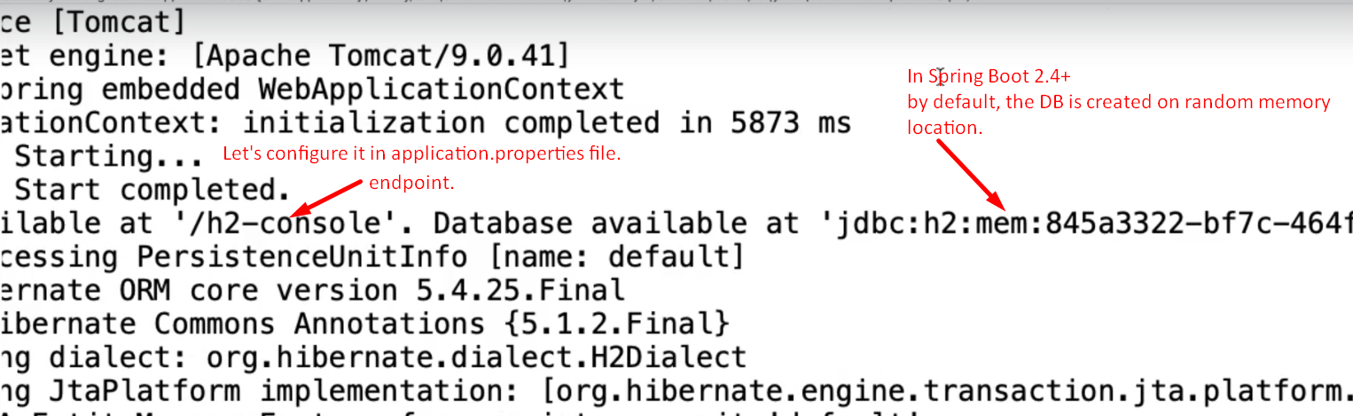
3. 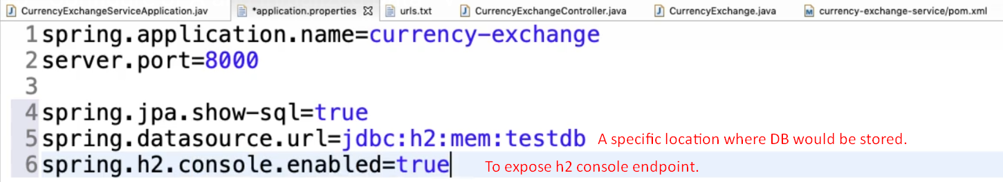
4. 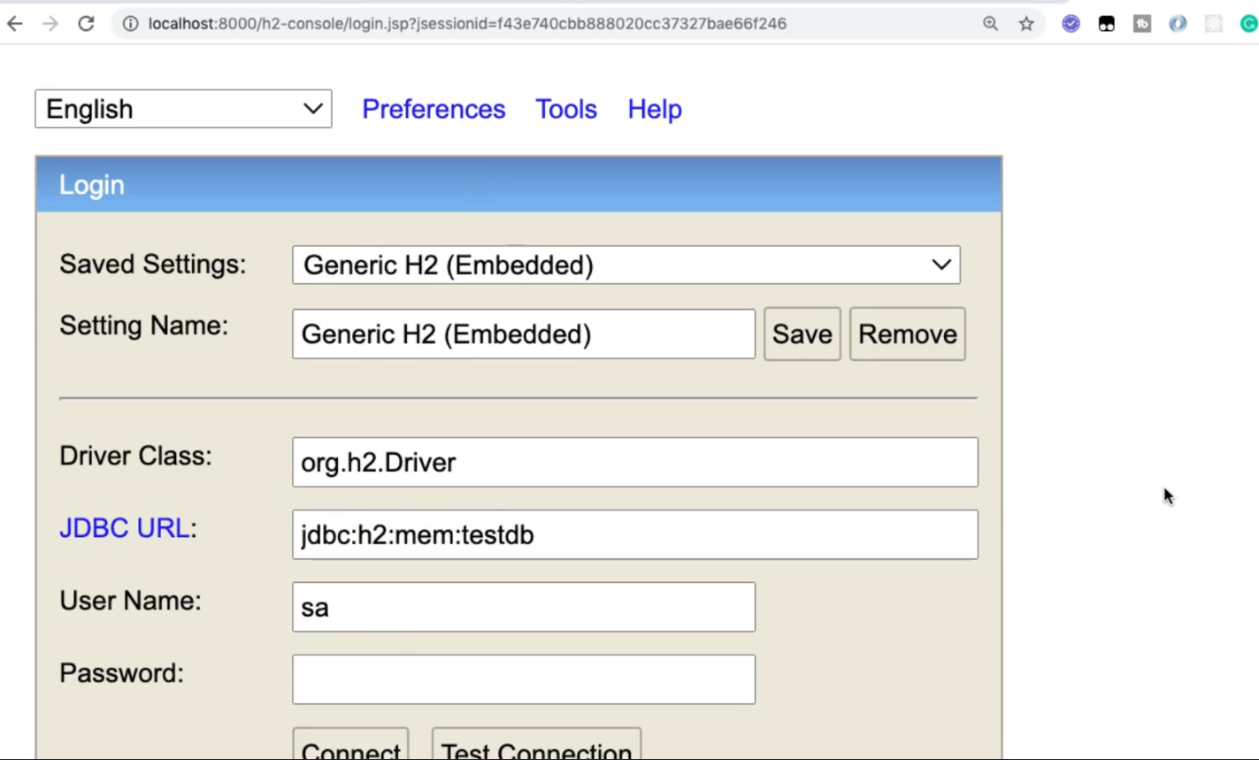
5. 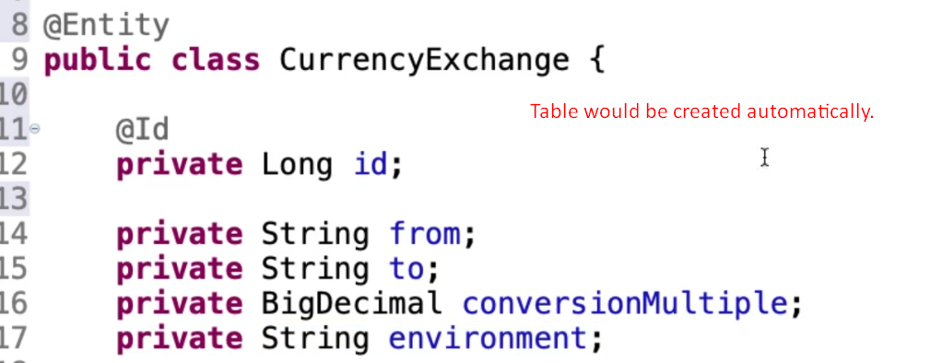
6. 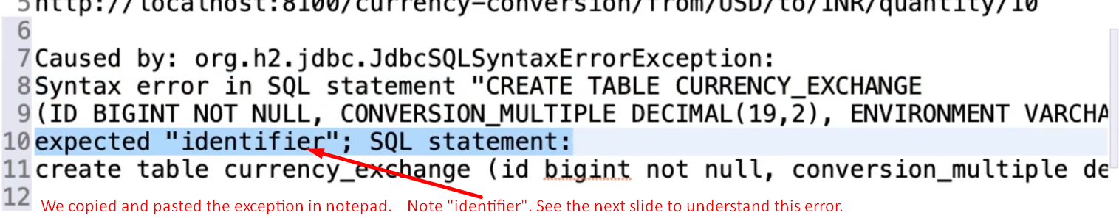
7. 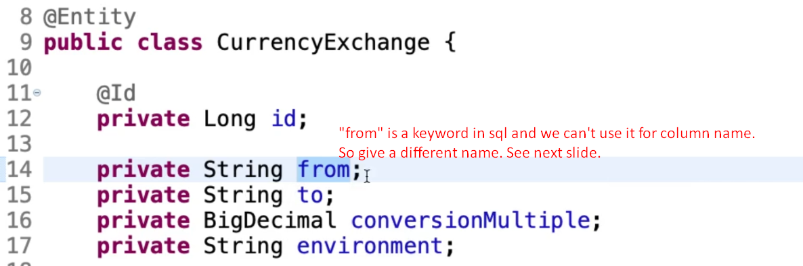
8. 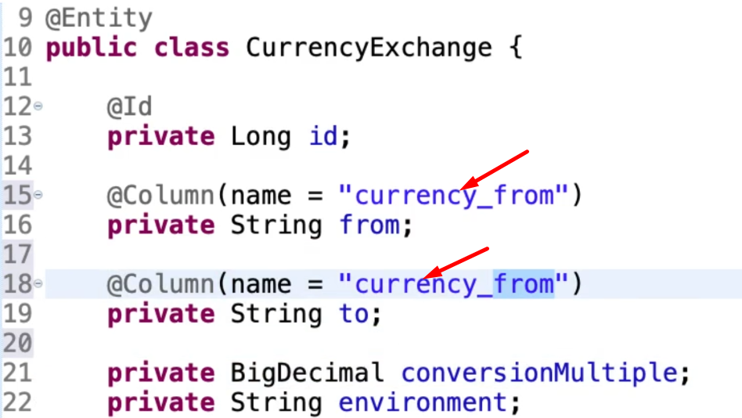
9. 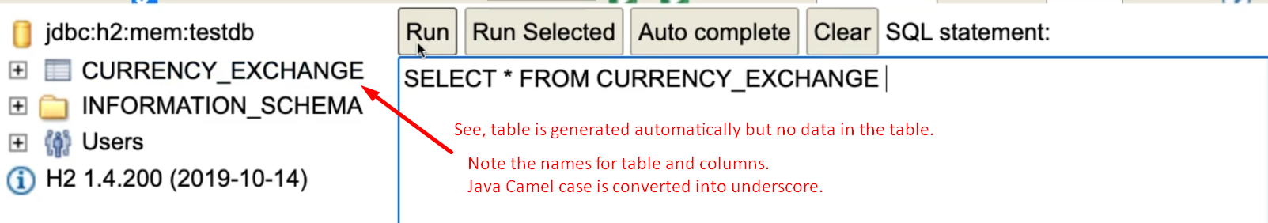
10. 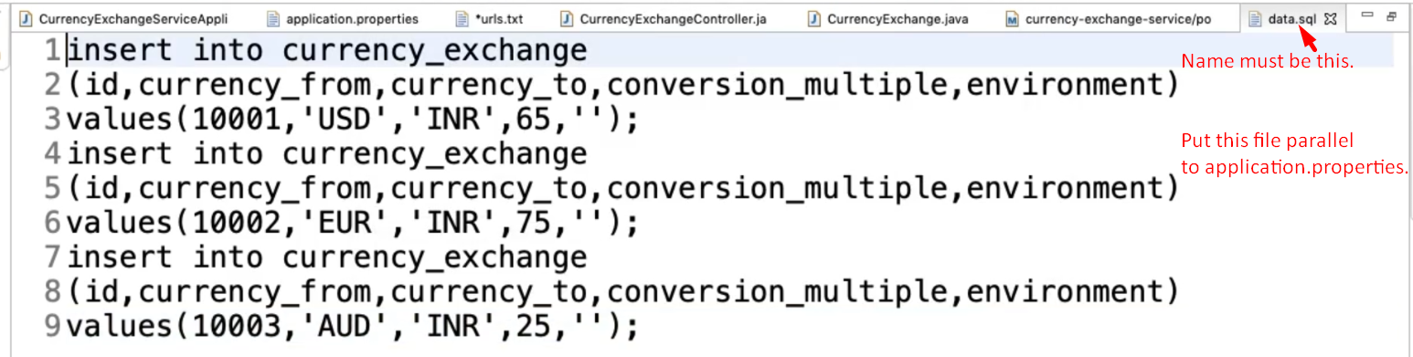
11.   
    **NOTE**: In prior Spring Boot version, the data.sql file is executed before the tables (@Entity) are created but we can defer the execution by configuring the application.properties file.  
    